Module – 5
Interaction and Audio
Interaction - Motor Programs and Remapping, Locomotion, Manipulation, Social Interaction,
Additional Interaction Mechanisms.
Audio-The Physics of Sound, Auditory Rendering- Basic signal processing, Acoustic modeling, Auralization.

- Interaction
The interaction concept deal with:
How should users interact with the virtual world?
How should they move about?
How can they grab and place objects?
How should they interact with representations of each other?
How should they interact with files or the Internet?
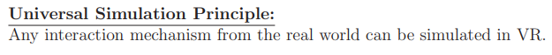
- For example, the user might open a door by turning a knob and pulling. As another example, the user operates a virtual aircraft by sitting in a mock-up cockpit.
- The goal is not necessarily realism. It is often preferable to make the interaction better than reality.
  - Motor Programs and Remapping
Motor Programs
- The examples for motor programs include writing text, tying shoelaces, throwing a ball, and riding a bicycle. We develop fine motor skills to accomplish these tasks through repetitive trials, with gradual improvements in precision and ease as the amount of practice increases.
- Eventually, we produce the motions without even having to pay attention to them. For example, most people can drive a car without paying attention to particular operations of the steering wheel, brakes, and accelerator.
- In the same way, most of us have learned how to use interfaces to computers, such as keyboards, mice, and game controllers.
- Some devices are easier to learn than others. For example, a mouse does not take long, but typing quickly on a keyboard takes years to master.
Design considerations
In the development of interaction mechanisms for VR, the main considerations are:
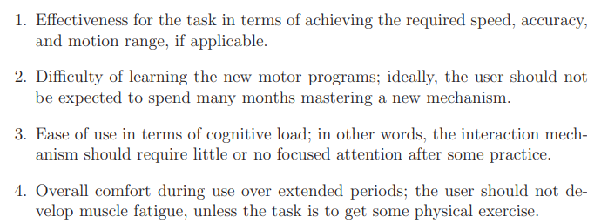
The neurophysiology of movement
- Figure 10.1(a), shows some parts of the cerebral cortex that are devoted to motion.
- The primary motor cortex is the main source of neural signals that control movement, whereas the premotor cortex and supplementary motor area appear to be involved in the preparation and planning of movement.
- Many more parts are involved in motion and communicate through neural signals, as shown in Figure 10.1(b).
- The most interesting part is the cerebellum, meaning “little brain”, which is located at the back of the skull. It seems to be a special processing unit that is mostly devoted to motion, but is also involved in functions such as attention and language.
- Damage to the cerebellum has been widely seen to affect fine motor control and learning of new motor programs. It has been estimated to contain around 101 billion neurons , which is far more than the entire cerebral cortex, which contains around 20 billion.
- Even though the cerebellum is much smaller, a large number is achieved through smaller, densely packed cells. In addition to coordinating fine movements, it appears to be the storage center for motor programs.

One of the most relevant uses of the cerebellum for VR is in learning sensorimotor relationships. Sensorimotor skills involve the process of receiving sensory messages (sensory input) and producing a response (motor output). We receive sensory information from our bodies and the environment through our sensory systems (vision, hearing, smell, taste, touch, vestibular, and proprioception).
All body motions involve some kind of sensory feedback. The most common example is hand-eye coordination; however, even if you move your arms with your eyes closed, proprioception provides information in the form of efference copies of the motor signals.
Sensor-feedback and motor control are combined in applications such as robotics and aircraft stabilization; the subject that deals with this is called control systems.

- One of the most important factors is how long it takes to learn a motor program. As usual, there is great variation across humans.
- A key concept is neuroplasticity, which is the potential of the brain to reorganize its neural structures and form new pathways to adapt to new stimuli. Toddlers have a high level of neuroplasticity, which becomes greatly reduced over time through the process of synaptic pruning.
- This causes healthy adults to have about half as many synapses per neuron than a child of age two or three. Unfortunately, the result is that adults have a harder time acquiring new skills such as learning a new language or learning how to use a complicated interface.
- In addition to the reduction of neuroplasticity with age, it also greatly varies among people of the same age.
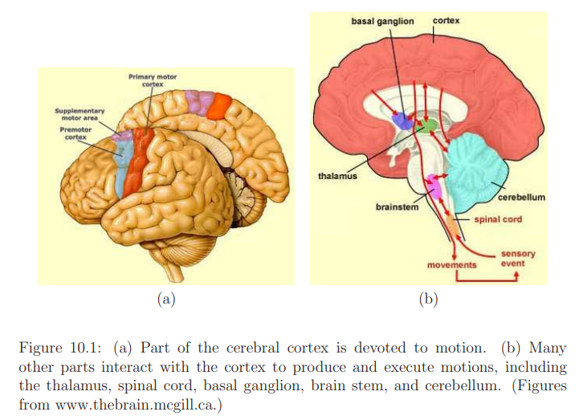
Learning motor programs
- Now consider learning a motor program for a computer interface.
- A simple, classic example is the video game Breakout, which was developed by Atari in 1976.
- The player turns a knob, shown in Figure 10.2. This causes a line segment on the bottom of the screen to move horizontally.
- The Paddle contains a potentiometer that with calibration allows the knob orientation to be reliably estimated.
- The player sees the line segment positioned on the bottom of the screen and quickly associates the knob orientations.
- The learning process therefore involves taking information from visual perception and the proprioception signals from turning the knob and determining the sensorimotor relationships.
- Skilled players could quickly turn the knob so that they could move the line segment much more quickly than one could move a small tray back and forth in the real world.
- This is an example where the virtual world version allows better performance than in reality.
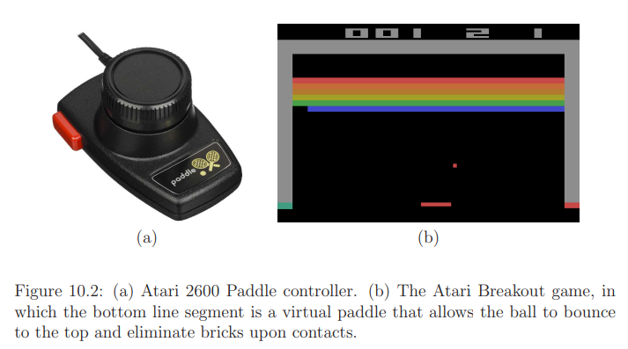
- In the Breakout example, a one-dimensional mapping was learned between the knob orientation and the line segment position. In the case of the Paddle, the motion is accomplished by the fingers, which have high dexterity, while the forearm moves much less.
- Many alternative control schemes could be developed:
- One is using keys on a keyboard to move the segment. In this case, the amount of time that a key is held down corresponds to the segment displacement. The segment velocity is set by the program, rather than the user.
- A reasonable alternative might be to move a finger back and forth over a touch screen while the segment appears directly above it.
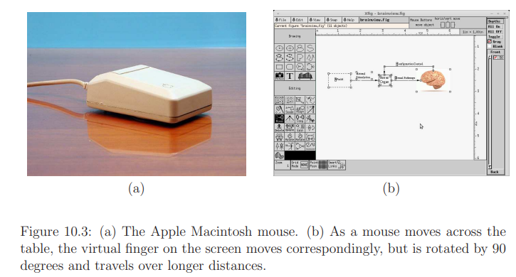
- Figure 10.3 shows a more familiar example, which is the computer mouse. As the mouse is pushed around on a table, encoders determine the position, which is converted into a pointer position on the screen.
- The sensorimotor mapping seems a bit more complex than in the Breakout example.
- The 2D position of the mouse is mapped to a 2D position on the screen, with two fundamental distortions: 1) The screen is rotated 90 degrees in comparison to the table (horizontal to vertical motion. 2) The motion is scaled so that small physical motions produce larger screen motions.
- Young children seem to immediately learn how to use the mouse, whereas older adults require some practice.
Motor programs for VR
- A perceptual experience is controlled by body movement that is sensed through a hardware device. Using the universal simulation principle, any of these and more could be brought into a VR system.
- Using the tracking methods, the position and orientation of body parts could be reliably estimated and brought into VR.
- For the case of head tracking, it is essential to accurately maintain the viewpoint with high accuracy and zero effective latency; otherwise, the VR experience is significantly degraded.
Remapping
- Remapping involves learning a sensorimotor mapping that produces different results in a virtual world than one would expect from the real world.
- Ie a motion in the real world may be mapped into a substantially different motion in the virtual world. This enables many powerful interaction mechanisms. The task is to develop ones that are easy to learn, easy to use, effective for the task, and provide a comfortable user experience.
- Ex: The process of pushing a pencil across paper to produce a letter has been replaced by pressing a key.
- The term remapping is even used with keyboards to mean the assignment of one or more keys to another key.
- Remapping is natural for VR. For example, rather than reaching out to grab a virtual door knob, one could press a button to open the door.
- For a simpler case, consider holding a controller for which the pose is tracked through space, as allowed by the HTC Vive system. A scaling parameter could be set so that one centimetre of hand displacement in the real world corresponds to two centimetres of displacement in the virtual world. This is similar to the scaling parameter for the mouse.
- Remapping example include converting natural walking in the real world to the equivalent one in a virtual world by using a controller.

  - Locomotion
Some form of interaction mechanism is needed to move the user in the virtual world while she remains fixed within the tracked area in the real world. An interaction mechanism that moves the user in this way is called locomotion. It is as if the user is riding in a virtual vehicle that is steered through the virtual world.
VR locomotion is technology that enables movement from one place to another (locomotion) within a virtual reality environment. Locomotion through a virtual environment is enabled by a variety of methods including head bobbing and arm swinging, as well as other natural movements that translate to in-game movements.
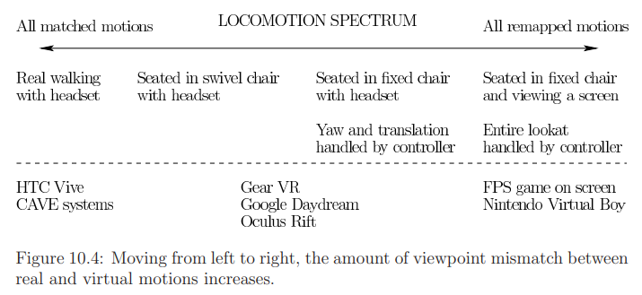
- Figure 10.4 shows a spectrum of common locomotion scenarios.
- At the left, the user walks around in an open space while wearing a headset.
- No locomotion is needed unless the virtual world is larger than the open space.
- This case involves no mismatch between real and virtual motions.
- The two center cases correspond to a seated user wearing a headset.
- In these cases, an interaction mechanism is used to change the position of the matched zone in the virtual world.
- If the user is seated in a swivel chair, then he could change the direction he is facing (yaw orientation) by rotating the chair. This can be considered as orienting the user’s torso in the virtual world.
- If the user is seated in a fixed chair, then the virtual torso orientation is typically changed using a controller, which results in more mismatch.
- The limiting case is on the right of Figure 10.4, in which there is not even head tracking.
- If the user is facing a screen, as in the case of a first-person shooter game on a screen, then a game controller is used to change the position and orientation of the user in the virtual world. This is the largest amount of mismatch because all changes in viewpoint are generated by the controller.
Redirected walking
If the user is tracked through a very large space, such as a square region of at least 30 meters on each side, then it is possible to make her think she is walking in straight lines for kilometers while she is in fact walking in circles. (ie user will be walking in circles but she feels like she is having a long distance walking).This technique is called redirected walking. This technique also uses other cues(eg:haptic) to modify our spatial perception.
Locomotion implementation
Consider the middle cases from Figure 10.4 of sitting down and wearing a headset. Locomotion can then be simply achieved by moving the viewpoint with a controller.
Consider the matched zone as a controllable cart that moves across the ground of the virtual environment; see Figure 10.5. First consider the simple case in which the ground is a horizontal plane. Let T_{track} denote the homogeneous transform that represents the tracked position and orientation of the cyclopean (center) eye in the physical world. The position and orientation of the cart is determined by a controller. The homogeneous matrix:
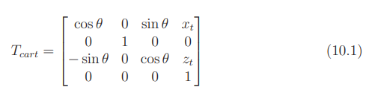
encodes the position (x_{t}, z_{t}) and orientation θ of the cart (as a yaw rotation). The height is set at y_{t} = 0 in (10.1) so that it does not change the height determined by tracking or other systems.
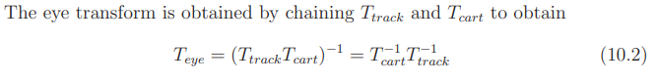
The eye transform is the inverse of the transform that places the geometric models. Therefore, (10.2) corresponds to changing the perspective due to the cart, followed by the perspective of the tracked head on the cart.
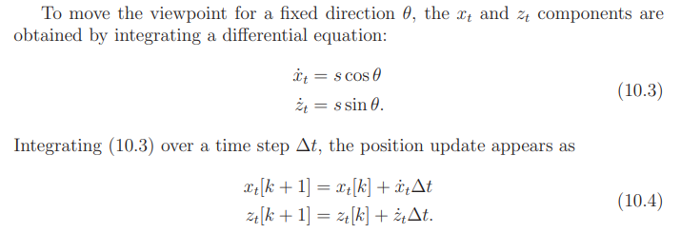
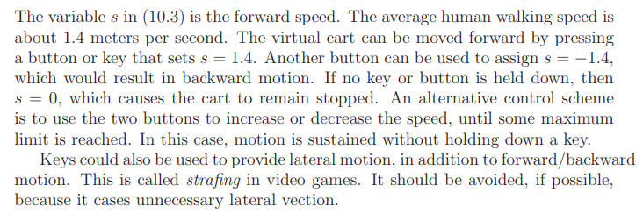
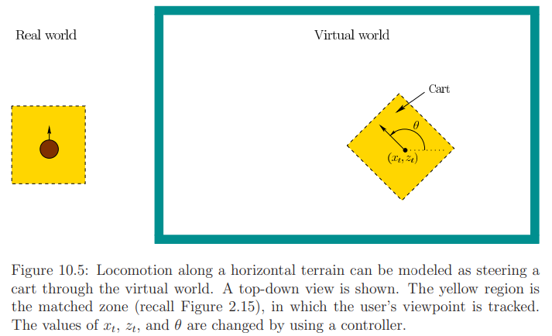
Issues with changing direction
Consider the orientation θ. To move in a different direction, θ needs to be reassigned. The assignment could be made based on the user’s head yaw direction. By rotating the swivel chair, the direction can be set.
In a fixed chair, it may become frustrating to control θ because the comfortable head yaw range is limited to only 60 degrees in each direction. In this case, buttons can be used to change θ by small increments in clockwise or counterclockwise directions. Unfortunately, changing θ according to constant angular velocity causes yaw vection, which is nauseating to many people. If the increments are too small, then vection appears again, and if the increments are too large, then users become confused about their orientation.
Another issue is where to locate the center of rotation, as shown in Figure 10.6. What happens when the user moves his head away from the center of the chair in the real world? Should the center of rotation be about the original head center or the new head center? If it is chosen as the original center, then the user will perceive a large translation as θ is changed. However, this would also happen in the real world if the user were leaning over while riding in a cart. If it is chosen as the new head center, then the amount of translation is less, but might not correspond as closely to reality.
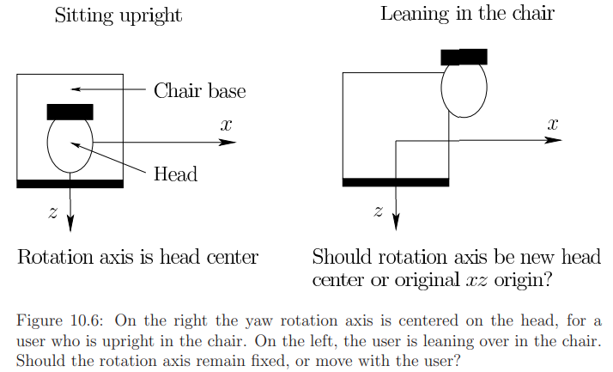
Vection reduction strategies
The main problem with locomotion is vection, which leads to VR sickness.
Several strategies for reducing vection-based VR sickness are:

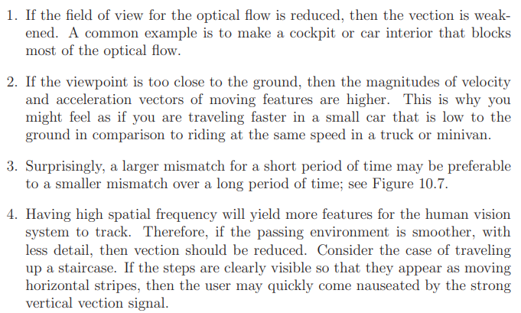
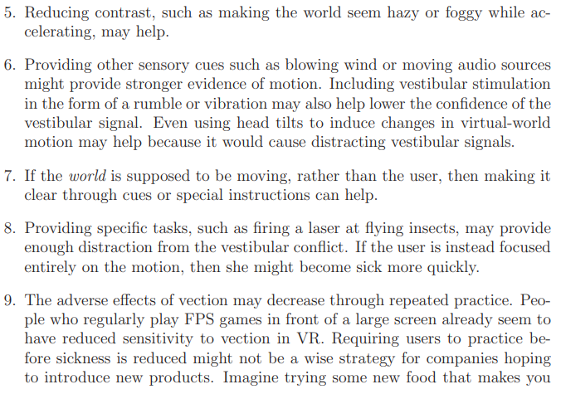
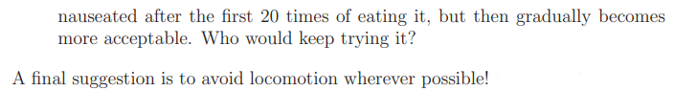
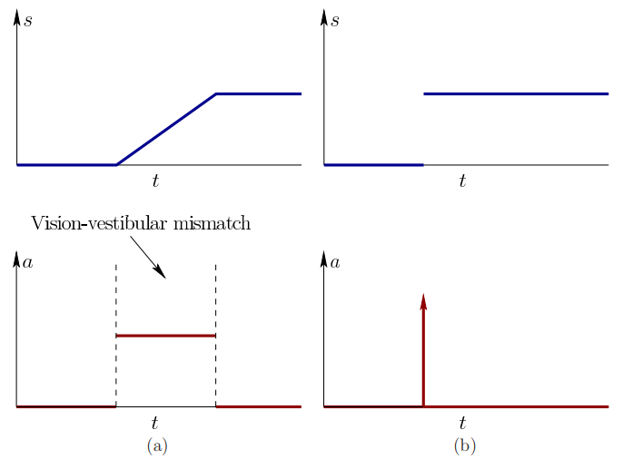
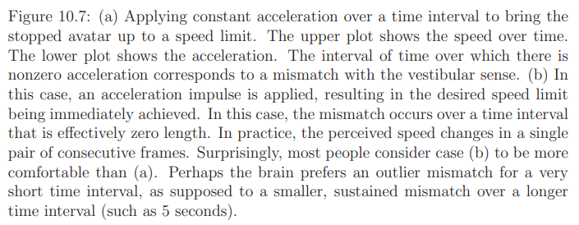
Non-planar locomotion
Consider more complicated locomotion cases. If the user is walking over a terrain, then the y component can be simply increased or decreased to reflect the change in altitude. This may seem realistic, but it increases the amount of mismatch between the real and virtual worlds because vertical vection is combined with forward vection.
In the case of moving through a 3D medium, all six forms of vection become enabled. Common settings include a virtual spacecraft, aircraft, or scuba diver. Yaw, pitch, and roll vection can be easily generated. For example, imagine flying a virtual spacecraft. By rolling the craft, roll vection can be caused as the stars spin around in a circular pattern. So prior suggestions for reducing vection intensity should be followed.
Furthermore, careful experimentation with human subjects should be performed to determine which forms of vection are worse in the particular application.
Adding special effects that move the viewpoint will cause further difficulty with vection. For example, making an avatar jump up and down will cause vertical vection. It is also a bad idea to account for swaying head motions while walking because of the increased mismatch. Imagine a far worse case of looking out through the eyes of an avatar that performs gymnastics. The view of the world may become unbearable during multiple flips.
Specialized hardware
Many kinds of hardware have been developed to support locomotion. One of the oldest examples is to create an entire cockpit for aircraft flight simulation. Figure 10.8(a) shows an omnidirectional treadmill that enables walking in any direction and over any distance. Exercise machines, such as a stationary bicycle have been connected to VR systems so that the user can pedal and steer to guide himself through a large virtual world, as shown in Figure 10.8(b).
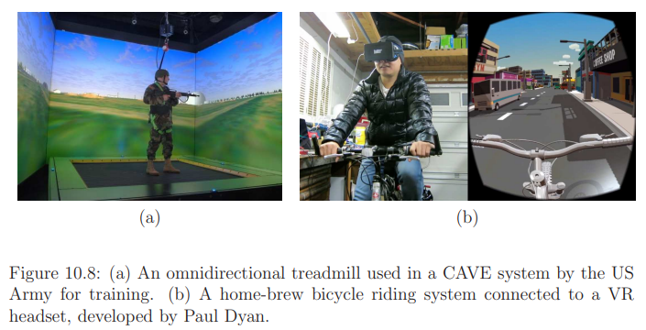
Teleportation
Here the user is immediately transported to another location.
How is the desired location determined?
One simple mechanism is a virtual laser pointer (or 3D mouse), which is accomplished by the user holding a controller that is similar in shape to a laser pointer in the real world. A smart phone could even be used. The user rotates the controller to move a laser dot in the virtual world. This requires performing a ray casting operation to find the nearest visible triangle, along the ray that corresponds to the laser light.
To select a location where the user would prefer to stand, she could simply point the virtual laser and press a key to be instantly teleported. To make pointing at the floor easier, the beam could actually be a parabolic arc that follows gravity, similar to a stream of water; see Figure 10.9. Places that are not visible can be selected by using a pop-up map, or even performing a text-based search (voice commands could be used instead of typing). One method, called world in miniature, involves showing the user a virtual small-scale version of the environment [318]. This is effectively a 3D map.
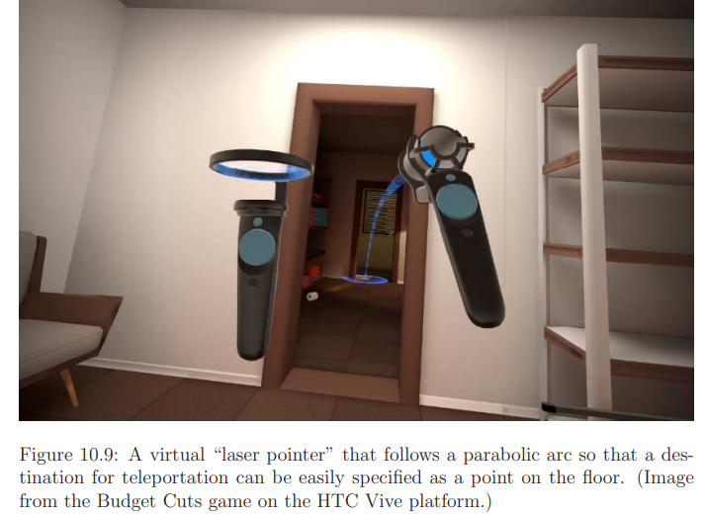
Wayfinding
The cognitive problem of learning a spatial representation and using it to navigate is called wayfinding.
One trouble with locomotion systems that are not familiar in the real world is that users might not learn the spatial arrangement of the world around them.
The teleportation mechanism reduces vection, and therefore VR sickness; however, it may come at the cost of reduced learning of the spatial arrangement of the environment. When performing teleportation, it is important not to change the yaw orientation of the viewpoint; otherwise, the user may become even more disoriented. He might not understand where he is now positioned and oriented in the virtual world relative to the previous location.
1.3 Manipulation
Manipulation presents ways in which the user may interact with other objects in the virtual world.
We interact with objects in the real world for many reasons. You might eat a bowl of soup by moving a spoon between the bowl and your mouth. You might pick up a rock and throw it as far as possible. You might put on a pair of pants. These examples and many more fall under the topic of manipulation.
In the real world, manipulation involves complex sensorimotor relationships which, through evolution and experience, enable us to manipulate different objects that vary in size, weight, friction, flexibility, temperature, fragility, and so on.
We apply the remapping concepts to make manipulation as simple as possible in VR.
Avoid gorilla arms
virtual reality (VR) activities that requires you to hold your arms up for long periods can cause gorilla arm.It is a condition in which the user quickly feels fatigue from extended arms.
Selection
One of the simplest ways to select an object in the virtual world is with the virtual laser pointer. Several variations may help to improve the selection process. For example, the user might instead hold a virtual flashlight that illuminates potential selections. The field of view of the flashlight could be adjustable. A virtual mirror could be placed so that a selection could be made around a corner.
With a pointer, the user simply illuminates the object of interest and presses a button. If the goal is to retrieve the object, then it can be immediately placed in the user’s virtual hand or inventory. If the goal is to manipulate the object in a standard, repetitive way, then pressing the button could cause a virtual motor program to be executed. This could be used, for example, to turn a doorknob, thereby opening a door.
If the object is hard to see, then the selection process may be complicated. It might be behind the user’s head, which might require uncomfortable turning. The object could be so small or far away that it occupies only a few pixels on the screen, making it difficult to precisely select it. The problem gets significantly worse if there is substantial clutter around the object of interest, particularly if other selectable objects are nearby. Finally, the object may be partially or totally occluded from view.
Manipulation
- If the user carries an object over a long distance, then it is not necessary for her to squeeze or clutch the controller; this would yield unnecessary fatigue.
- Suppose user want an object to move it around in his hand to determine its 3D structure. The object orientation could be set to follow exactly the 3D orientation of a controller that the user holds.
- The user could even hold a real object in hand that is tracked by external cameras, but has a different appearance in the virtual world.
- Having a longer arm than normal can also be simulated, to retrieve and place objects over greater distances.

Placement
Now consider ungrasping the object and placing it into the world. An easy case for the user is to press a button and have the object simply fall into the right place. This is accomplished by a basin of attraction which is an attractive potential function defined in a neighborhood of the target pose.
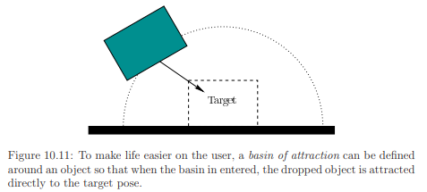
Remapping
The simplest case of remapping is the use of the button to select, grasp, and place objects. Instead of a button, continuous motions could be generated by the user and tracked by systems. Examples include turning a knob, moving a slider bar, moving a finger over a touch screen, and moving a free-floating body through space.
To avoid gorilla arms and related problems, a scaling factor could be imposed on the tracked device so that a small amount of position change in the controller corresponds to a large motion in the virtual world.
Current systems
- The development of interaction mechanisms for manipulation remains one of the greatest challenges for VR.
- Current generation consumer VR headsets either leverage existing game controllers, as in the bundling of the XBox 360 controller with the Oculus Rift in 2016, or introduce systems that assume large hand motions are the norm, as in the HTC Vive headset controller, as shown in Figure 10.12.
- Others are developing gesturing systems that involve no hardware in the hands, as in the Leap Motion system.
- Rapid evolution of methods and technologies for manipulation can be expected in the coming years, with increasing emphasis on user comfort and ease of use.
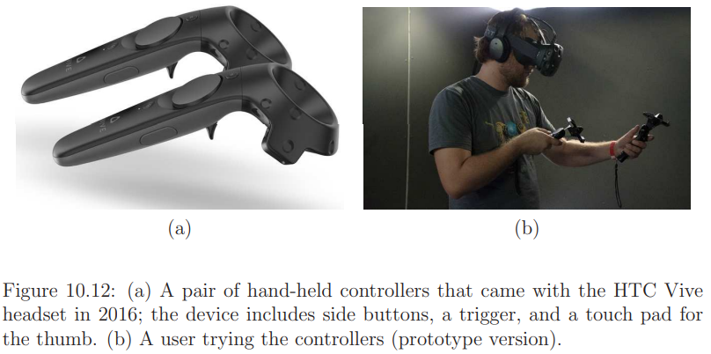
1.4 Social Interaction
- Social Interaction allow users to interact directly with each other.
- Connecting humans together is one of the greatest potentials for VR technology.
- Social interaction in VR, or social VR, remains in a stage of infancy, with substantial experimentation and rethinking of paradigms occurring.
Beyond Shannon-Weaver communication
- An important factor is how many people will be interacting through the medium.
- Start with a pair of people.
- One of the most powerful mathematical models ever developed is the Shannon-Weaver model of communication.
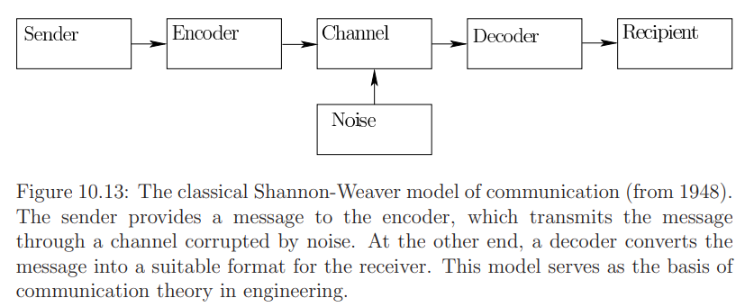
- The model involves a sender and a recipient.
- The communication system encodes a message from the sender, which is then sent over a noisy channel.
- At the other end, the system decodes the message and it arrives to the recipient.
- The recipient could give feedback to indicate whether the message has been received intact.
- This communication model gave rise to the field of information theory, which enabled the notion of bandwidth for a communication channel and revealed the limits of data compression.
- In spite of its shortcomings for VR, the Shannon-Weaver model provides powerful analysis of bandwidth and latency for computer networks and systems, which ultimately support any form of social interaction.
- One key problem is to ensure that the targeted social interaction VR experience is comfortable, convincing, and reliably supported over the computer network.
From avatars to visual capture
How should others see you in VR? There are many possibilities.
- At one extreme, a user may represent himself through an avatar, which is a 3D representation that might not correspond at all to his visible, audible, and behavioral characteristics. See Figure 10.14.
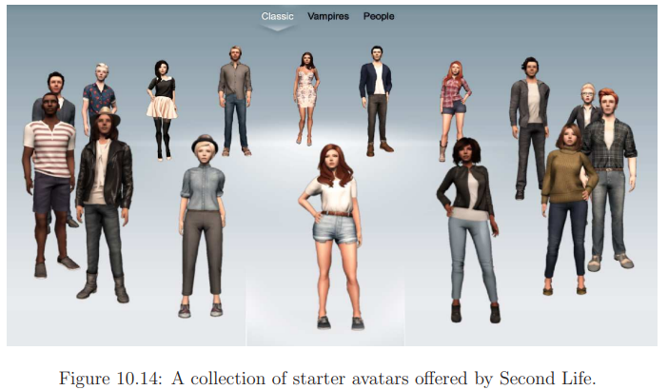
- At the other extreme, a user might be captured using imaging technology and reproduced in the virtual world with a highly accurate 3D representation; see Figure 10.15. In this case, it may seem as if the person were teleported directly from the real world to the virtual world.
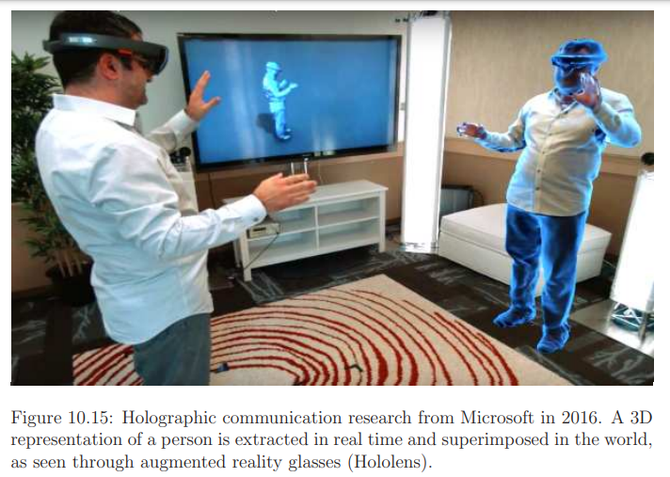
- One major appeal of an avatar is anonymity, which offers the chance to play a different role or exhibit different personality traits in a social setting.
- In a phenomenon called the Proteus effect, it has been observed that a person’s behavior changes based on the virtual characteristics of the avatar, which is similar to the way in which people have been known to behave differently when wearing a uniform or costume.
- The user might want to live a fantasy, or try to see the world from a different perspective.
- For example, people might develop a sense of empathy if they are able to experience the world from an avatar that appears to be different in terms of race, gender, height, weight, age, and so on.
- Users may also want to experiment with other forms of embodiment. For example, a group of children might want to inhabit the bodies of animals while talking and moving about.
- Imagine if you could have people perceive you as if you as an alien, an insect, an automobile, or even as a talking block of cheese.
- People were delightfully surprised in 1986 when Pixar brought a desk lamp to life in the animated short Luxo Jr.
- Hollywood movies over the past decades have been filled with animated characters, and we have the opportunity to embody some of them while inhabiting a virtual world!
Based on the current technology, three major kinds of similarity (physical realism) can be independently considered:
1. Visual appearance: How close does the avatar seem to the actual person in terms of visible characteristics?
2. Auditory appearance: How much does the sound coming from the avatar match the voice, language, and speech patterns of the person?
3. Behavioral appearance: How closely do the avatar’s motions match the body language, gait, facial expressions, and other motions of the person?

- We could match the person in real world by making a kinematic model in the virtual world that corresponds in size and mobility to the actual person. Other simple matching such as hair color, skin tone, and eye color could be performed.
- To further improve realism, texture mapping could be used to map skin and clothes onto the avatar. For example, a picture of the user’s face could be texture mapped onto the avatar face.
- Highly accurate matching might also be made by constructing synthetic models, or combining information from both imaging and synthetic sources. Some of the best synthetic matching performed to date has been by researchers at the USC Institute for Creative Technologies; see Figure 10.16.
- But a frustrating problem is that people often describe computer-generated animation that tends toward human realism as seeing zombies or talking cadavers. Thus, being far from perfectly matched is usually much better than “almost” matched in terms of visual appearance.

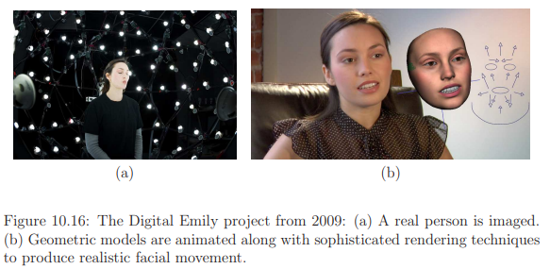
- For the auditory part, users of Second Life and similar systems have preferred text messaging.
- Texting helps to ensure anonymity.
- Recording and reproducing voice is simple in VR, making it much simpler to match auditory appearance than visual appearance.
- One must take care to render the audio with proper localization, so that it appears to others to be coming from the mouth of the avatar.
- If desired, anonymity can be easily preserved in spite of audio recording by using real-time voice-changing software (such as MorphVOX or Voxal Voice Changer); this might be preferred to texting in some settings.
- Also the behavioral experience could be matched perfectly, while the avatar has a completely different visual appearance.
- This is the main motivation for motion capture systems, in which the movements of a real actor are recorded and then used to animate an avatar in a motion picture.
- But accurate, real-time performance that perfectly matches the visual and behavioral appearance of a person is currently unattainable in low-cost VR systems.
- Furthermore, capturing the user’s face is difficult if part of it is covered by a headset, although some recent progress has been made in this area.
- Current tracking systems can be used to provide accurately matched behavioral appearance in some instances. For example, head tracking can be directly linked to the avatar head so that others can know where the head is turned.
- Users can also understand head nods or gestures, such as “yes” or “no”.
- Figure 10.17 shows a simple VR experience in which friends can watch a movie together while being represented by avatar heads that are tracked (they can also talk to each other).
- In some systems, eye tracking could also be used so that users can see where the avatar is looking.
- If the hands are tracked, which could be done using controllers, then they can also be brought into the virtual world.
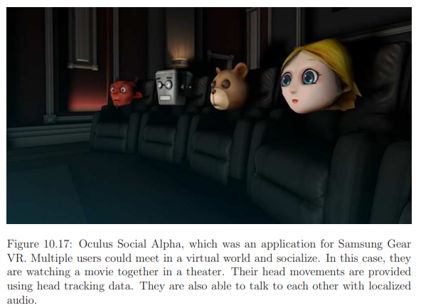
From one-on-one to societies
- The majority of one-on-one interaction that we have in the real world is with people we know.
- One important aspect of one-on-one communication is whether the relationship between the two people is symmetrical or complementary.
- In a symmetrical relationship the two people are of equal status, whereas in a complementary relationship one person is in a superior position, as in the case of a boss and employee or a parent and a child. This greatly affects the style of interaction, particularly in a targeted activity.
- Now consider interactions within a small group of people in the real world. Perhaps a family or coworkers are sharing a meal together. Perhaps children are together on a playground. Perhaps friends and family have gathered for a holiday or birthday celebration. VR versions of such interactions could focus on a targeted activity, such as gathering for a party. Perhaps you are the one who could not attend in person, but will instead “hang out” with the group through some VR interface.
- Perhaps there is a meeting, and a few people need to attend remotely, which is currently handled by teleconferencing, in which voice and video are transmitted over the network.
- The common scenario that is closest to VR is schoolchildren meeting in a networked video game, with some social interaction occurring while they play. They might form teams and interact through text messaging or voice while playing.
- As the number of people increases to over a dozen, the case of a complementary relationship leads to a presentation or interview. Some examples are a teacher lecturing to a class of students, and a politician speaking in front of a group of reporters. In these interactions, a leader has been clearly assigned to communicate with the group. The entire event could take place in a virtual world.
- In the case of a symmetrical relationship, people might mingle at a large reception, and carry on conversations in small groups. This could also be reproduced in VR.
- In the limiting case, an online community may emerge, which could connect millions of users. Examples include MMORPGs and Second Life.
- People may have casual interactions by bumping into each other while spending a significant amount of time living or working in a networked virtual world.
- One issue, which exists in any online community, is membership. Are they open to everyone, or only a closed group?
Transformed social interaction
- VR can produce experiences that are better than reality.
- The notion of transformed social interaction has been introduced Jeremy Bailenson.
- It deals with how social interaction can be altered or improved through VR.
- A thought-provoking example is shown in Figure 10.18.
- In a virtual world, a teacher could look at every student simultaneously, directly in the eyes, while lecturing to the class. This is physically impossible in the real world, but it is easy to make in VR because each student could see a different version of the virtual world. The chance that she might be watching could have a significant effect on learning outcomes.
- The classroom could also appear to have a small number of students, while in reality thousands of students are in attendance.
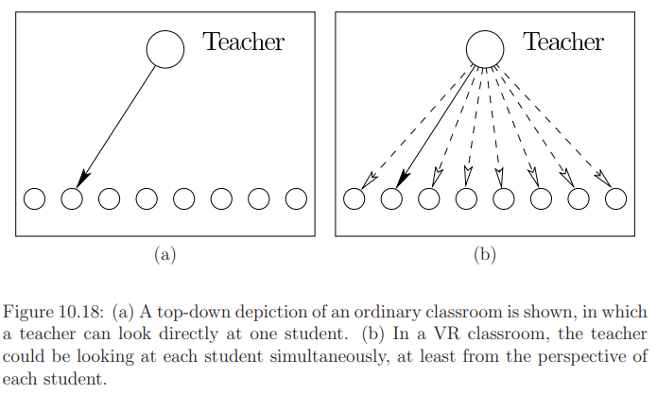
1.5 Additional Interaction Mechanisms
A few examples of other interaction mechanisms and associated challenges are presented here.
Interaction with information and media
- The content of the Internet can be brought into VR in numerous ways by following the universal simulation principle.
- For example a movie screen in a virtual movie theatre can be made. In this case, simple interaction may be needed to pause or change the movie.
- As a more complex example, a web browser could appear on a public display in the virtual world or on any other device that is familiar to users in the real world.
- Alternatively, a virtual screen may float directly in front of the user, while a stable, familiar background is provided; see Figure 10.19.
- For decades, people have interacted with the computers and web browsers using two input devices, one for typing and the other for pointing. In the case of a PC, this has taken the form of a keyboard and mouse. With modern smartphones, people are expected to type on small touch screens, or use alternatives such as voice or swipe-to-type. They use their fingers to point by touching, and additionally zoom with a pair of fingers.

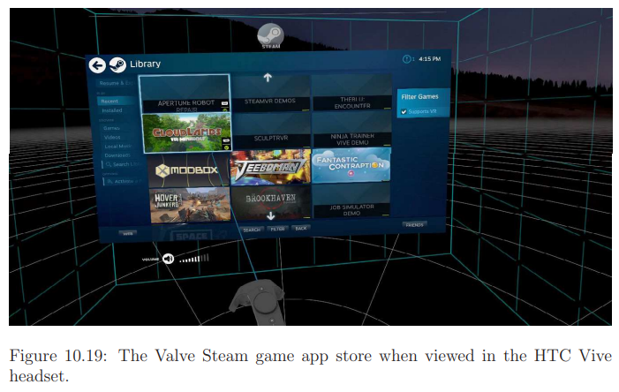
Audio
  - The physics of sound
Light is a transverse wave, which oscillates in a direction perpendicular to its propagation, sound is a longitudinal wave, which oscillates in a direction parallel to its propagation. Figure 11.1 shows an example of this for a parallel wavefront.
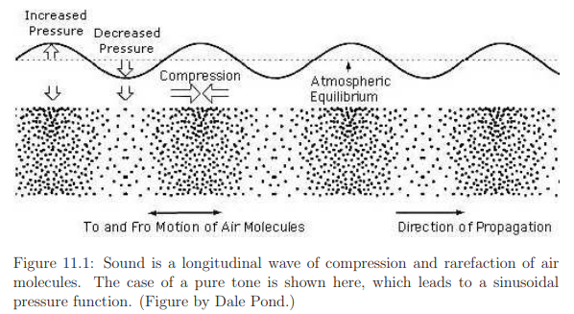
Sound corresponds to vibration in a medium, which is usually air, but could also be water, or any other gases, liquids, or solids. There is no sound in a vacuum, which is unlike light propagation. For sound, the molecules in the medium displace, causing variations in pressure that range from a compression extreme to a decompressed, rarefaction extreme. At a fixed point in space, the pressure varies as a function of time. This could be the pressure variation on a human eardrum, which is converted into a perceptual experience. The sound pressure level is frequently reported in decibels (dB), which is defined as
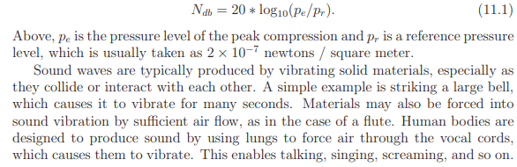
Sound sources and attenuation
As in the case of light, we can consider rays, for which each sound ray is perpendicular to the sound propagation wave front. A point sound source can be defined, which produces emanating rays with equal power in all directions.
Due to energy lost in the vibration of molecules, the sound intensity decreases by a constant factor (or fixed percentage) for every unit of distance from the planar source; this is an example of exponential decay. Attenuation refers to the reduction in the intensity, power, or magnitude of a sound signal. Acoustic attenuation can occur in several ways: as the sound dissipates through the air when absorbed by another medium, when it is reflected against a barrier, or by interference from other ambient noise.
Propagation speed
Sound waves propagate at 343.2 meters per second through air at 20◦ C (68◦ F). For comparison, light propagation is about 874,000 times faster. We have planes and cars that can surpass the speed of sound, but are nowhere near traveling at the speed of light. This is perhaps the most important difference between sound and light for making VR systems.

Frequency and wavelength
The frequency is the number of compressions per second and is called pitch. The range is generally considered to be from 20 Hz to 20,000 Hz, which is based on human hearing, much in the same way that the frequency range for light is based on human vision. Vibrations above 20,000 Hz are called ultrasound, and are audible to some animals. Vibrations below 20 Hz are called infrasound.
If propagation speed, s = 343.2, at 20 Hz, the wavelength is λ = 343.2/20 = 17.1m.

Doppler effect
If the point is moving away from the source, then the wavefronts will arrive at a reduced frequency. For example, if the receiver moves at 43.2m/s away from the source, then the waves would seem to be traveling at only 343.2 − 43.2 = 300 meters per second. The received frequency shifts due to the relative motion between the source and receiver. This is known as the Doppler effect, and the frequency as measured at the receiver can be calculated as
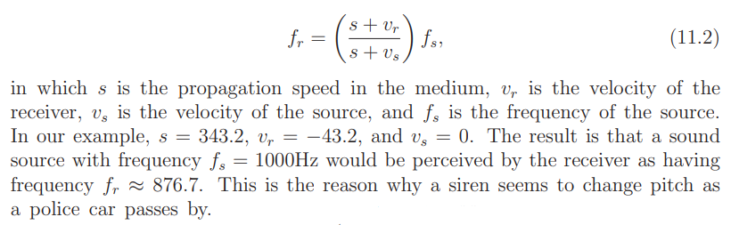

Reflection and transmission
As with light, wave propagation is strongly effected by propagation through media. Imagine a sound wave hitting an interior wall as someone yells from inside of a room. Due to reflection, much of the sound will bounce as if the wall were an acoustic mirror. However, some of the sound energy will penetrate the wall. Sounds propagates more quickly through more solid materials, resulting in a bending of the ray as it penetrates. This is refraction. Some of the sound escapes the far side of the wall and propagates through the air in an adjacent room, resulting in transmission. Thus, someone in the adjacent room can hear yelling. The total amount of energy contained in the sound waves before it hits the wall is split by reflection and transmission, with additional loss due to attenuation.

Diffraction
Wavefronts can also bend around corners, which is called diffraction; see Figure 11.2. This would enable someone to hear a sound that is around the corner of a building, without relying on any reflection or transmission. More diffraction occurs for longer wavelengths; thus, a lower-pitched sound bends around corners more easily.
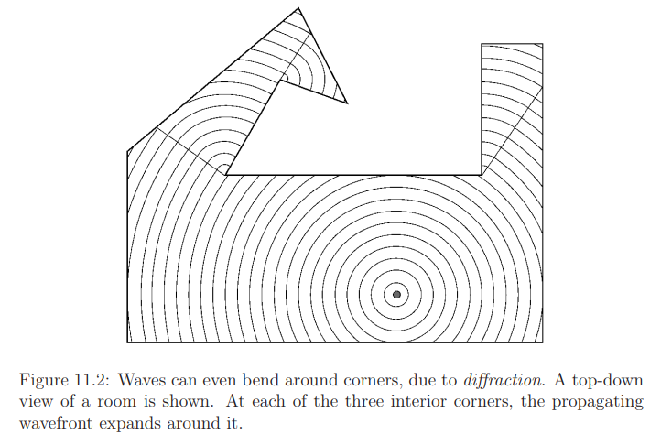

Fourier analysis
A Fourier series is an expansion of a periodic function into a sum of trigonometric functions. A sinusoidal wave, as shown in Figure 11.3(a), corresponds to a pure tone, which has a single associated frequency; this is analogous to a color from the light spectrum. A more complex waveform, such the sound of a piano note, can be constructed from a combination of various pure tones. Figures 11.3(b) to 11.3(d) provide a simple example. This principle is derived from Fourier analysis, which enables any periodic function to be decomposed into sinusoids (pure tones in our case) by simply adding them up. Each pure tone has a particular frequency, amplitude or scaling factor, and a possible timing for its peak, which is called its phase. By simply adding up a finite number of pure tones, virtually any useful waveform can be closely approximated. The higher-frequency, lower-amplitude sinusoids are often called higher-order harmonics; the largest amplitude wave is called the fundamental frequency. The plot of amplitude and phase as a function of frequency is obtained by applying the Fourier transform.
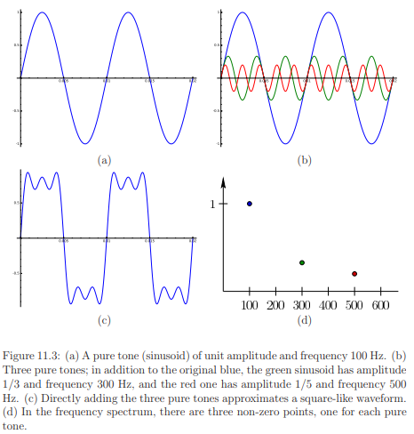
  - Auditory Rendering
Sounds for the virtual world, should be consistent with visual cues. Whether recorded sounds, synthetic sounds, or a combination, the virtual pressure waves and their rendering to speakers should sufficiently fool the user’s brain.
1.2.1 Basic Signal Processing
Signal processing is an electrical engineering subfield that focuses on analyzing, modifying and synthesizing signals. In our case the signals are sound waves that could be fully synthesized, captured using microphones, or some combination.
Figure 11.12 shows the overall scheme. The original signal appears in the upper left. First, follow the path from left to right. The signal enters a black box labeled linear filter and becomes distorted, as shown in the right.
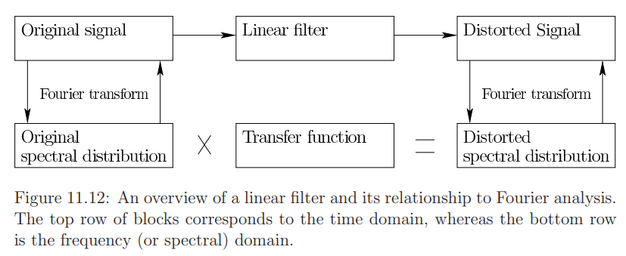

Sampling rates
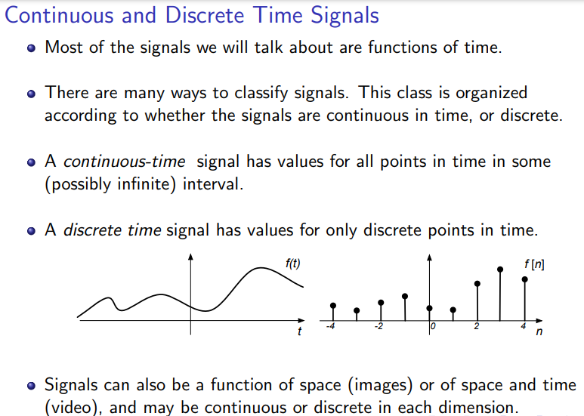
Because of its practical value, we will focus on the discrete-time case.
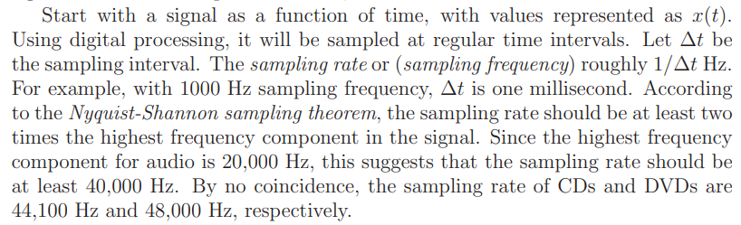
By sampling the signal, an array of values is produced. At 1000 Hz, the array
Linear filters
In the field of signal processing, a filter is a device or process that, completely or partially, suppresses unwanted components or features from a signal. This usually means removing some frequencies to suppress interfering signals and to reduce background noise.
A filter is a transformation that maps one signal to another. Each signal is a function of time, and the filter is like a black box that receives the one signal as input, and produces another as output. If x represents an entire signal (over all times), then let F(x) represent the resulting signal after running it through the filter.
A linear filter is a special kind of filter that satisfies two algebraic properties. The first algebraic property is additivity, which means that if two signals are added and sent through the filter, the result should be the same as if they were each sent through the filter independently, and then the resulting transformed signals were added. Using notation, this is F(x + x ′) = F(x) + F(x ′) for any two signals x and x ′. For example, if two different sounds are sent into the filter, the result should be the same whether they are combined before or after the filtering. This concept will become useful as multiple sinusoids are sent through the filter.
The second algebraic property is homogeneity, which means that if the signal is scaled by a constant factor before being sent though the filter, the result would be the same as if it were scaled by the same factor afterwards. Using notation, this means that cF(x) = F(cx) for every constant c and signal x. For example, this means that if we double the sound amplitude, then the output sound from the filter doubles its amplitude as well.
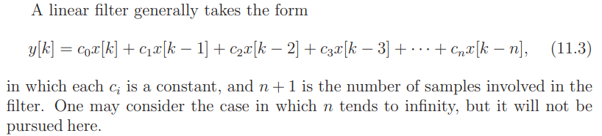
This particular form is a causal filter. The word causal indicates that the filter output depends only on past and present inputs. A filter whose output also depends on future inputs is non-causal, whereas a filter whose output depends only on future inputs is anti-causal.
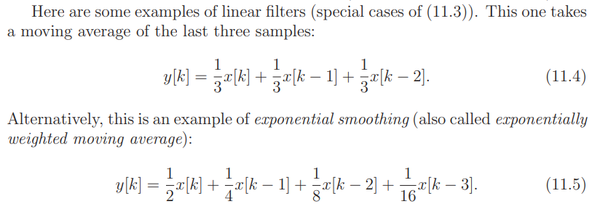
Finite impulse response
A finite impulse is a signal for which x[0] = 1 and x[k] = 0 for all k > 0. Any other signal can be expressed as a linear combination of time-shifted finite impulses. If a finite impulse is shifted, for example x[2] = 1, with x[k] = 0 for all other k ≠2, then a linear filter produces the same result, but it is just delayed two steps later.
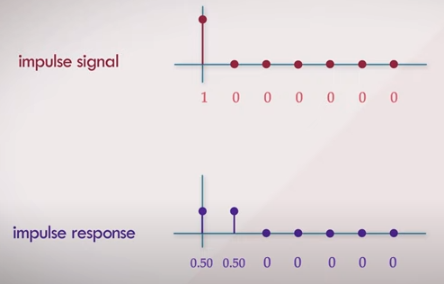
Since there are a finite number of non-zero values in the impulse response (in this case its only 2), this is regarded as a finite impulse response (FIR). In general all filters which are purely feed forward have a finite impulse response.
The filter in (11.3) is often called an FIR filter.
Nonlinear filters
Any (causal) filter that does not follow the form (11.3) is called a nonlinear filter. The operation of the human auditory system is almost a linear filter, but exhibits characteristics that make it into a nonlinear filter. Linear filters are preferred because of their close connection to spectral analysis, or frequency components, of the signal.
Returning to Fourier analysis
Now consider the bottom part of Figure 11.12. The operation of a linear filter is easy to understand and compute in the frequency domain. This is the function obtained by performing the Fourier transform on the signal, which provides an amplitude for every combination of frequency and phase. Formally, it is defined for discrete-time systems as
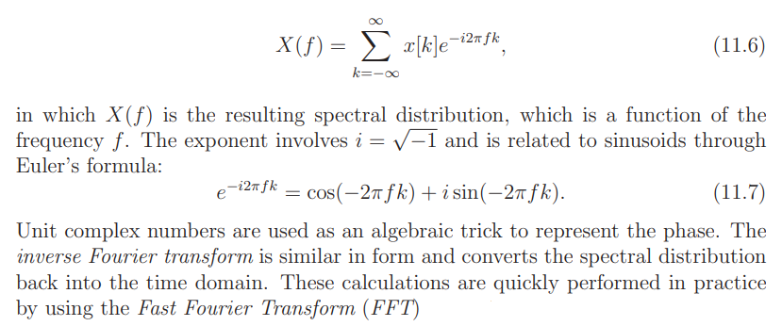
Transfer function
In some cases, a linear filter is designed by expressing how it modifies the spectral distribution. It could amplify some frequencies, while suppressing others. In this case, the filter is defined in terms of a transfer function, which is applied as follows: 1) transforming the original signal using the Fourier transform, 2) multiplying the result by the transfer function to obtain the distorted spectral distribution, and then 3) applying the inverse Fourier transform to obtain the result as a function of time. The transfer function can be calculated from the linear filter by applying the discrete Laplace transform (called z-transform) to the finite impulse response.
1.2.2 Acoustic modelling
The geometric modeling concepts can be applied to the auditory side of VR as well. Walls that reflect light in the virtual world also reflect sound waves. Therefore, both could be represented by the same triangular mesh.
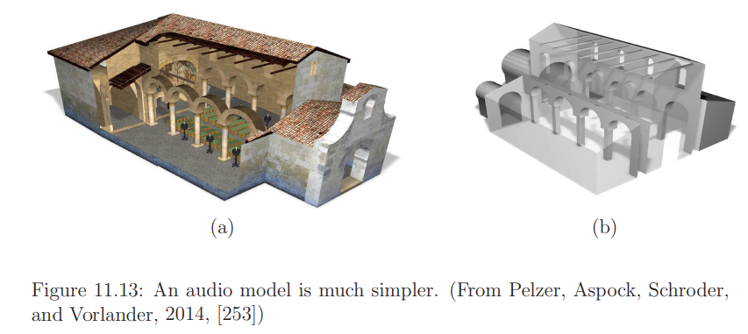
The acoustic model needs to have a spatial resolution of only 0.5m. Figure 11.13 shows an example. Thus, any small corrugations, door knobs, or other fine structures can be simplified away. It remains an open challenge to automatically convert a 3D model designed for visual rendering into one optimized for auditory rendering.
Consider a sound source in the virtual environment. This could, for example, be a “magical” point that emits sound waves or a vibrating planar surface. The equivalent of white light is called white noise, which in theory contains equal weight of all frequencies in the audible spectrum.
How does the sound interact with the surface? This is analogous to the shading. In the case of light, diffuse and specular reflections occur with a dependency on color. In the case of sound, the same two possibilities exist, again with a dependency on the wavelength (or equivalently, the frequency). For a large, smooth, flat surface, a specular reflection of sound waves occurs, with the outgoing angle being equal to the incoming angle. The reflected sound usually has a different amplitude and phase. The amplitude may be decreased by a constant factor due to absorption of sound into the material. The factor usually depends on the wavelength (or frequency).
In the case of smaller objects, or surfaces with repeated structures, such as bricks or corrugations, the sound waves may scatter in a way that is difficult to characterize. This is similar to diffuse reflection of light, but the scattering pattern for sound may be hard to model and calculate.
At the extreme end of modeling burdens, a bidirectional scattering distribution function (BSDF) could be constructed. It is used to name the general mathematical function which describes the way in which the light is scattered by a surface.
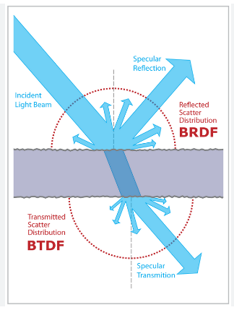

Capturing sound
Sounds could also be captured in the real world using microphones and then brought into the physical world. For example, the matched zone might contain microphones that become speakers at the equivalent poses in the real world. As in the case of video capture, making a system that fully captures the sound field is challenging.
1.2.3 Auralization
Propagation of sound in the virtual world
As in visual rendering, there are two main ways to handle the propagation of waves. The most expensive way is based on simulating the physics as accurately as possible, which involves computing numerical solutions to partial differential equations that precisely model wave propagation.
The cheaper way is to shoot visibility rays and characterize the dominant interactions between sound sources, surfaces, and ears.
The choice between the two methods also depends on the particular setting; some systems involve both kinds of computations. If the waves are large relative to the objects in the environment, then numerical methods are preferred. In other words, the frequencies are low and the geometric models have a high level of detail. At higher frequencies or with larger, simpler models, visibility-based methods are preferable.
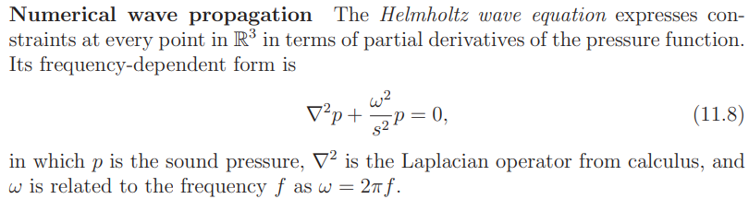
The wave equation is defined over the obstacle-free portion of the virtual world. The edge of this space becomes complicated, leading to boundary conditions. One or more parts of the boundary correspond to sound sources, which can be considered as vibrating objects or obstacles that force energy into the world. At these locations, the 0 in (11.8) is replaced by a forcing function.
At the other boundaries, the wave may undergo some combination of absorption, reflection, scattering, and diffraction. These are extremely difficult to model. In some rendering applications, these boundary interactions may simplified and handled with simple Dirichlet boundary conditions and Neumann boundary conditions. If the virtual world is unbounded, then an additional Sommerfield radiation condition is needed. An example of a numerically computed sound field is shown in Figure 11.14.
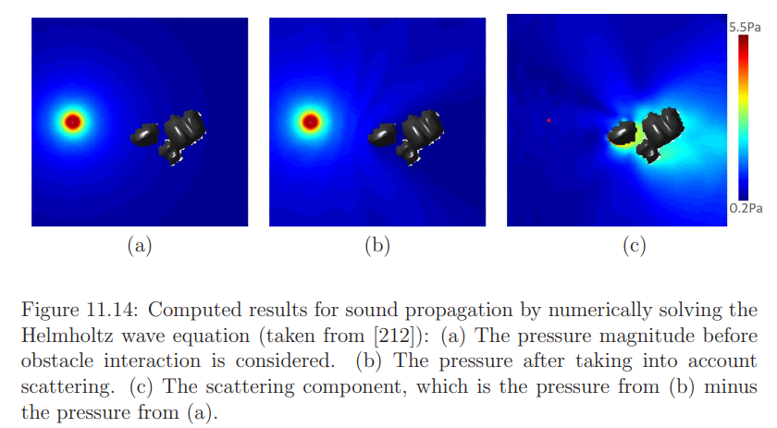
Visibility-based wave propagation
The alternative to numerical computations, which gradually propagate the pressure numbers through the space, is visibility-based methods, which consider the paths of sound rays that emanate from the source and bounce between obstacles. The methods involve determining ray intersections with the geometric model primitives.
Figure 11.15 shows the simple case of the impulse response for reflections in a rectangular room. Visibility-based methods are particularly good at simulating the reverberations, which are important to reproduce for perceptual reasons. More generally, visibility-based methods may consider rays that correspond to all of the cases of reflection, absorption, scattering, and diffraction. Due to the high computational cost of characterizing all rays, stochastic ray tracing offers a practical alternative by randomly sampling rays and their interactions with materials ;this falls under the general family of Monte Carlo methods, which are used, for example, to approximate solutions to high-dimensional integration and optimization problems.
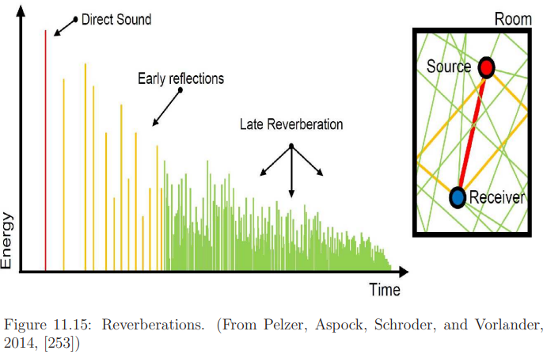
Entering the ear
Sound that is generated in the virtual world must be transmitted to each ear in the physical world. It is as if a virtual microphone positioned in the virtual world captures the simulated sound waves. These are then converted into audio output through a speaker that is positioned in front of the ear. Interaural time differences (ITDs) and interaural level differences (ILDs) cues can be used here.
HRTFs
Head Related Transfer Function (HRTF) describes how a given sound wave input is filtered by the diffraction and reflection properties of the head, pinna, and torso, before the sound reaches the transduction machinery of the eardrum and inner ear. The idea is to treat this distortion as a linear filter, which can be characterized in terms of its transfer function. This is accomplished by placing a human subject into an anechoic chamber and placing sound sources at different locations in the space surrounding the head. At each location, an impulse is generated on a speaker, and the impulse response is recorded with a small microphone placed inside of the ear canal of a human or dummy. The locations are selected by incrementally varying the distance, azimuth, and elevation.
Tracking issues
The final challenge is to ensure that the physical and virtual ears align in the matched zone. If the user turns her head, then the sound should be adjusted accordingly. If the sound emanates from a fixed source, then it should be perceived as fixed while turning the head. This is another example of the perception of stationarity. Accordingly, tracking of the ear pose (position and orientation) is needed to determine the appropriate “viewpoint”. This is equivalent to head tracking with simple position and orientation offsets for the right and left ears.

QUESTIONS
- Briefly explain the interaction mechanisms. (3 marks)
- Which are the main considerations in the development of interaction mechanisms for VR. (3 marks)
- What is remapping? (3 marks)
- Which all are the vection reduction strategies? (7 marks)
- Explain about motor programs and remapping? (14 marks)
- Explain about Locomotion? (14 marks)

